

Internship Report

Name: Holkar Kalyani Suryakant

Domain name: Python Development

Duration: 1 Month

Task Name : Number Guessing Game

Task performed : 2

# Task 2 : Number Guessing Game

# Introduction

During my internship as a Python developer, I had the opportunity to work on a number guessing game project. The main objective of the project was to create a game that would allow users to guess a random number generated by the computer within a specific range. The development of this game involved using several concepts and tools that I had previously learned in Python, such as variables, loops, conditional statements, and functions.

In this report, I will provide a detailed overview of the development process of the number guessing game, including the project requirements, design, implementation, and testing. I will also highlight the challenges I encountered during the development process and the strategies I used to overcome them.

Overall, this project provided me with valuable hands-on experience in Python development, and I believe that the skills and knowledge gained from this internship will be invaluable in my future endeavors.

# Task no.2

NUMBER GUESSING GAME

1.Define game rules such as the range of numbers to guess from and the number of guesses allowed.

2.Use Python's random module to generate a random number within the range for the player to guess.

3.Prompt the user to input a guess and validate the input to make sure it is a valid integer within the range.

4.Compare the user's guess with the generated random number and provide feedback on whether the guess is too high, too low, or correct.

5.Keep track of the number of guesses remaining and provide feedback to the user on their progress.

6.When the user guesses correctly, display the final score and allow the user to choose to play again.

The Number Guessing Game is a Python project that involves creating a game in which users have to guess a random number generated by the computer within a specified range. The game has specific rules that dictate the range of numbers to guess from and the number of guesses allowed. The project involves using Python's random module to generate a random number, prompting the user to input a guess, validating the input, comparing the user's guess with the generated random number, and providing feedback on the progress. The game keeps track of the number of guesses remaining and provides feedback to the user on their progress. When the user guesses correctly, the game displays the final score and allows the user to choose to play again. Overall, the Number Guessing Game is an excellent project for learning and implementing fundamental Python concepts and tools such as variables, loops, conditional statements, and functions.

Code

import random  
  
print("**************Welcome to Number Guessing Game!!!************")  
print("---------------Let's check your guessing---------------\n")  
print("Please understand the rules:")  
print("1) Choose the range.")  
print("2) If the pop-up message is 'high', then enter a smaller number.")  
print("3) If the pop-up message is 'small', then enter a higher number.")  
print("4) After guessing the correct number, you will see the message 'Win'.\n")  
  
lower = int(input("Enter the lower bound of the range: "))  
upper = int(input("Enter the upper bound of the range: "))  
  
if lower == upper:  
 print("The lower and upper bounds are the same. The number to guess is:", lower)  
else:  
 num = random.randint(lower, upper)  
 max_attempts = 7  
  
 print("\nYou have", max_attempts, "chances to win.\n")  
  
 for guess in range(1, max_attempts + 1):  
 attempt = int(input("Attempt {} - Guess a number between {} and {}: ".format(guess, lower, upper)))  
 if lower <= attempt <= upper:  
 if attempt < num:  
 print("Entered number is too small.")  
 elif attempt > num:  
 print("Entered number is too high.")  
 else:  
 print("Congratulations! You win the game in", guess, "attempts.")  
 break  
 else:  
 print(f"Invalid input. Please enter a number within the range {lower}-{upper}.")  
 else:  
 print("Sorry, your given chances are finished. The number to guess was:", num)  
  
print("\nThank you for playing the game!")

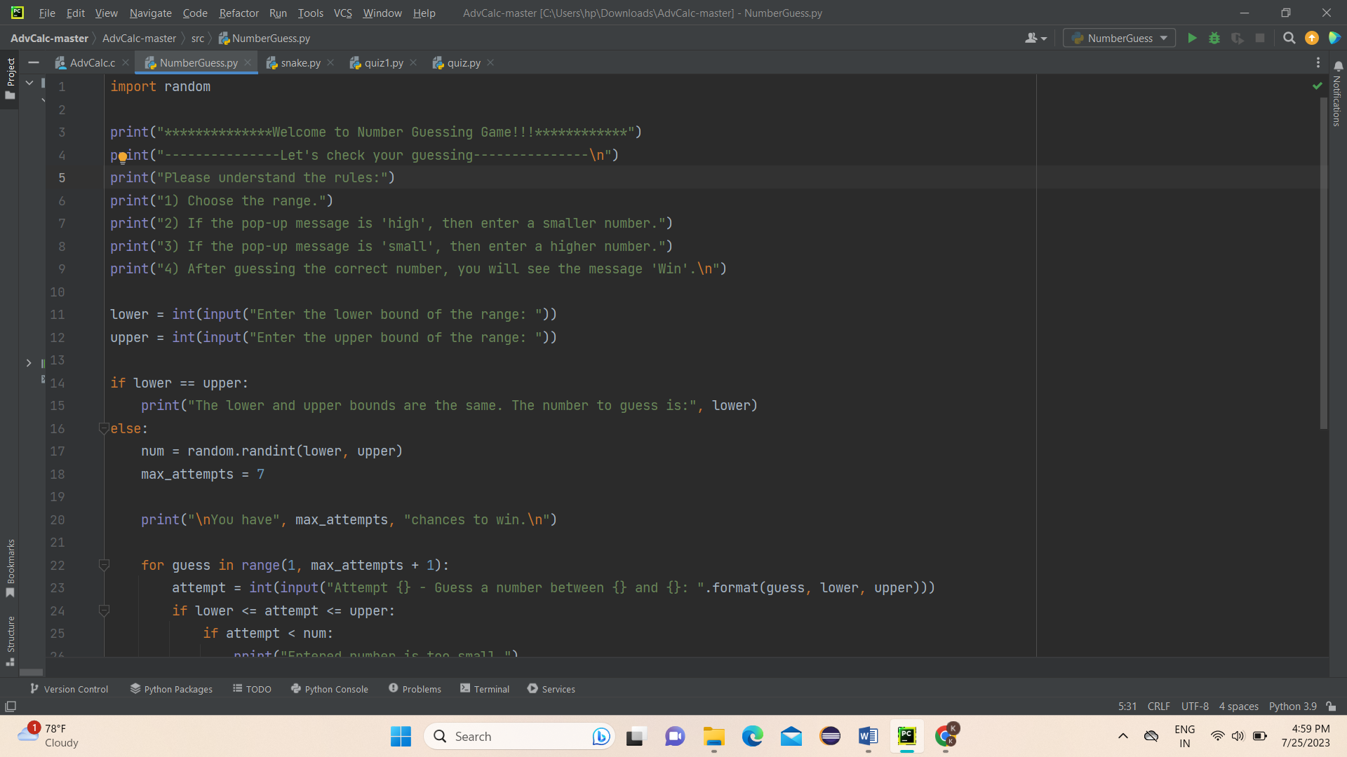

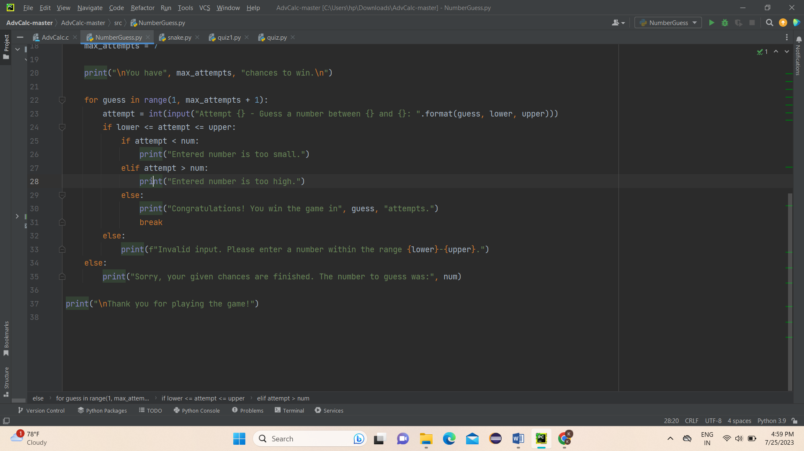

Output

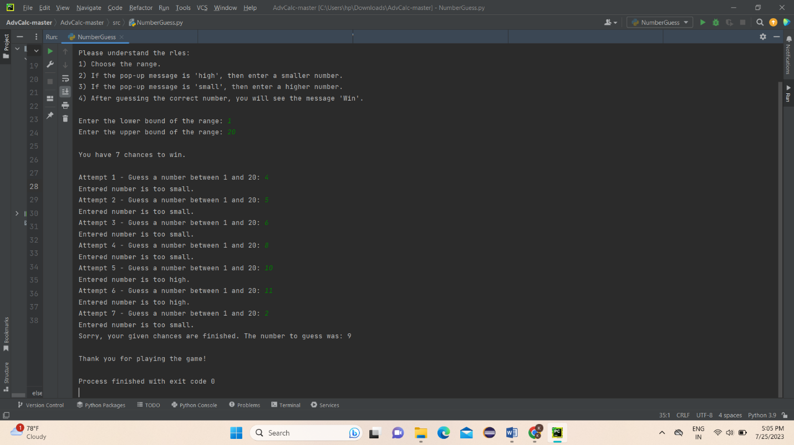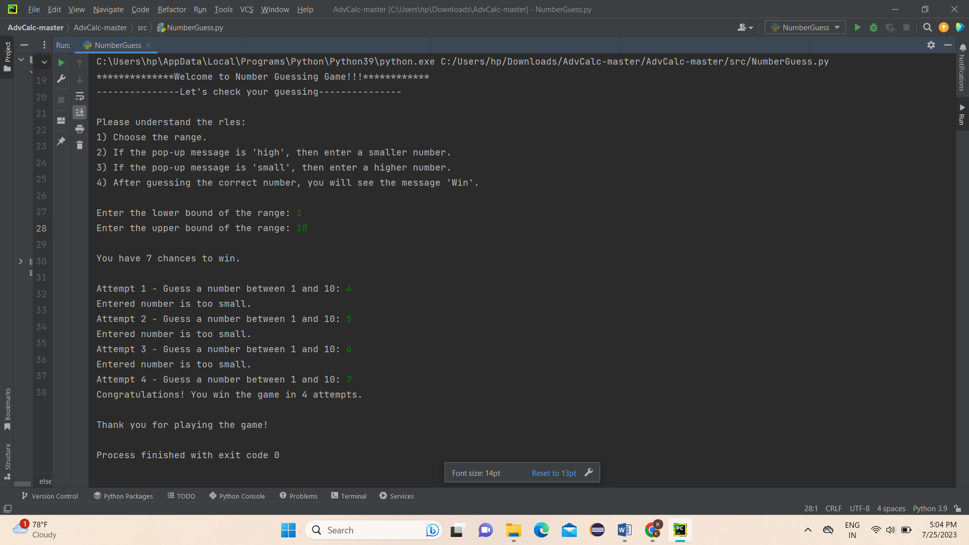

# Conclusion

Number Guessing Game :

In conclusion, the number guessing game project was an exciting and challenging experience that helped me hone my Python development skills. Through the project, I learned how to use several essential concepts and tools in Python to create a fully functional game that offers an engaging user experience. I was able to apply my knowledge of variables, loops, conditional statements, and functions to develop a game that meets the project requirements and offers an enjoyable experience for the user.

Throughout the development process, I encountered several challenges, such as validating user input and handling errors effectively. However, through careful planning, research, and implementation, I was able to overcome these challenges and create a game that performs as expected.

Overall, my experience in developing the number guessing game has been invaluable in helping me gain practical experience and build my confidence as a Python developer. I believe that the skills and knowledge gained from this internship will serve me well in my future endeavors, and I look forward to applying these skills to more advanced projects.